EzSchoolApps New Parent/Guardian Sign Up
- Open EzSchoolApps.com Click on the Parent Login
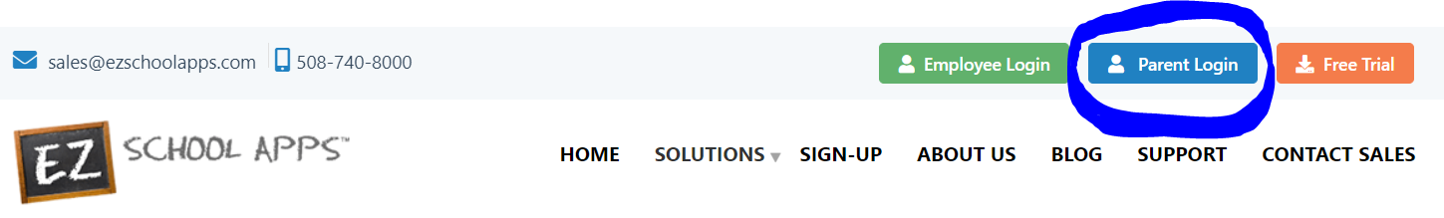
- Click on Sing-up today:
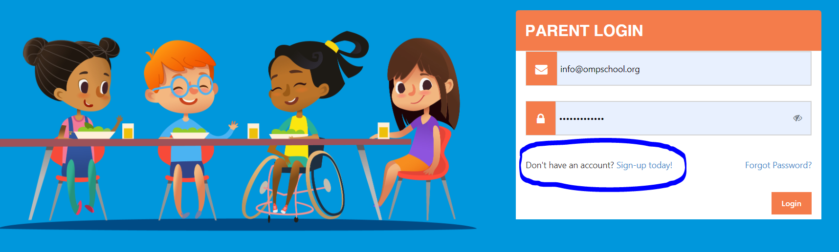
- Enter OMPS’ zip code: 49686
- Select: Old Mission Peninsula School
- Fill out this form:
